**User Guideline Document for *Dungeons and Wishes***

1. **Introduction**

“Dungeons and Wishes” is a 2D topdown view fantasy role playing game which aims to provide people with a nostalgic vibe with modern features and story telling, offering greatly enhanced users experience. This game focuses primarily on veteran rpg players who used to play game in gameboyadvance and bring those same nostalgic taste in computer.

From this project, players will be able to enjoy smooth movement, traditional turn-based combat system which challenges players with strategic battles against enemies and bosses. Interaction with the game world, and NPC’s with simple dialouges, item and equipment usage and context specific actions which will add depth to gameplay. There will be comprehensive inventory system which will be user friendly, enabling players to easily manage their items, equipment, and resources. Exploration will be the key features with varieties of puzzles. A robust progression system allowing player to level up, unlock new abilities and improve their stats during combat. To enhance immersion, the game includes camera shaking effects during significant events, such as powerful attacks or dramatic cutscenes. A reliable save-load features will be added ensuring the players to continure and reset their journet without losing any progression. Sound and effects will be added in order to keep player engage with beautiful tracks. An inventory system which will save all the item of player and can be able to use those item during turn base battle.

**2. System Requirements (Windows)**

**Minimum Requirements**

* OS: Windows 7 SP1+ (64-bit)
* Processor: Intel Core i3-2100 or AMD equivalent
* Memory: 4 GB RAM
* Graphics: Intel HD Graphics 4000 or equivalent (integrated GPU)
* DirectX: Version 10
* Storage: 2 GB available space
* Display: 1280x720 resolution minimum
* Input: Keyboard and mouse

**Recommended Requirements**

* OS: Windows 10 or 11 (64-bit)
* Processor: Intel Core i5-8400 / AMD Ryzen 5 2600 or better
* Memory: 8 GB RAM
* Graphics: NVIDIA GeForce GTX 950 / AMD Radeon R7 370 or better (dedicated GPU)
* DirectX: Version 11
* Storage: 8 GB available space
* Display: 1920x1080 resolution
* Input: Keyboard and mouse, with optional gamepad support

**3. Installation and Launch Instructions**

**Installing the Game**

1. Visit the official https://github.com/PrabalGurung/DungeonAndWishesV1
2. Click on the green "Code" button, then select "Download ZIP".
3. Once the ZIP file is downloaded, right-click it and choose "Extract All..." to unzip the folder.
4. Open the extracted folder.

**Launching the Game**

1. Inside the folder, locate the file named DungeonsAndWishes.exe.
2. Double-click the file to launch the game.
3. If a Windows security prompt appears, click "More info" > "Run anyway".

***Tip:*** *You can right-click the .exe file and choose “Send to > Desktop (create shortcut)” to make launching the game easier in the future.*

**4. Game Overview**

* Genre and style (e.g., "2D Top-Down Fantasy RPG").
* Objective of the game.
* Short backstory/lore (if needed).

**5. Controls**

|  |  |
| --- | --- |
| **Action** | **Keyboard/Mouse Input** |
| Move Character | WASD / Arrow Keys |
| Interact | Z |
| Open Inventory | Tab |
| Back | X |

**6. User Interface Explanation**

* Annotated screenshot showing:
  + Inventory UI

* + Setting UI

* + Stats UI

* + Map UI

* + NPC:

* + Items:

* + Dialogue box

* + Battle menu (turn-based)

* + Item UI

* + Skill UI

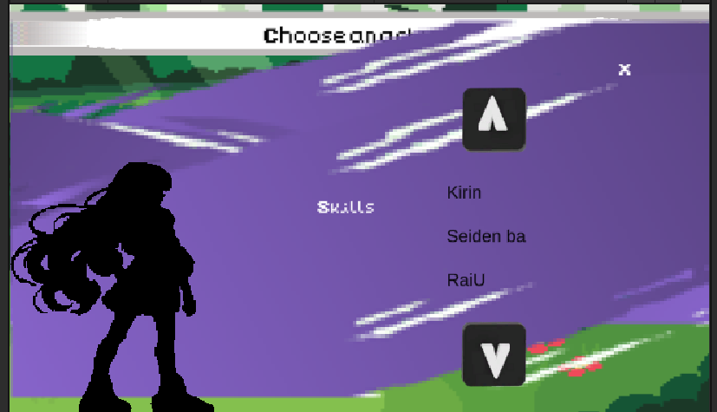

* + Status Bar

* + Dialouge box UI Turn base:



**7. Gameplay Mechanics**

**Movement & Exploration:** Players can navigate the world using intuitive controls for exploration, including movement through towns, dungeons, and outdoor environments.

**Combat System:** A turn-based combat system allows players to plan strategic attacks and defenses against enemies.

**Inventory Management:** Players can collect, equip, use, or drop items from their inventory to enhance their character’s abilities and progress.

**Dialogue:** Engaging dialogue with NPCs unfolds the story, offering choices that influence the narrative and character relationships.

**Battle Encounters:** Randomly triggered battles keep the gameplay dynamic and offer players varied challenges as they explore.

**Saving & Loading Progress:** The game offers both manual and auto-save features to ensure players can preserve their progress.

**Buying & Selling:** NPC merchants offer a variety of goods for purchase, each with unique items that players can use or sell for profit.

**Auto Generated Map:** Randomly generated cave systems and environments ensure that each playthrough feels unique and challenging.

**Different Monsters & Skills:** A wide range of monsters, each with distinct abilities, challenges players to adapt their strategy and skills.

**Sound System:** An immersive sound design enhances the game atmosphere with background music, sound effects, and voice acting.

**Score Difficulty System:** The AI adapts to the player’s performance, increasing in difficulty as the player improves, providing an ongoing challenge.

**Player Progress Bar:** As the player gains experience, a progress bar tracks their growth, allowing them to level up and unlock new abilities.

**Environment Interaction:** Players can interact with the environment to solve puzzles, trigger events, and discover hidden paths.

**Hidden Secrets and Easter Eggs:** Hidden secrets and easter eggs offer additional rewards and unlockables for curious players.

**Unlockable Skills & Powers:** Players can unlock new skills and powers throughout the game, enhancing their combat abilities and gameplay experience.

**8. Common Issues / FAQs**

* Game won’t start?
* How to save/load?
* Can’t interact with object/NPC?

**9. Tips for Beginners**

* Don’t skip dialogues—they may contain hints.
* Save often before entering a dungeon.

**10. Contact & Support**

* Email for reporting bugs or feedback through the main menu page of the game.